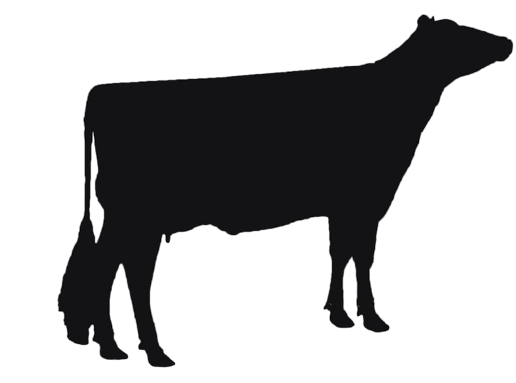

Kansas
Dairy
Kansas Dairy A collaboration of the Kansas Dairy Association and Kansas Dairy Commission.
Providing a unified voice for Kansas Dairy.

Associate Membership

Non-producers may join the Kansas Dairy Association as associate members to help strengthen our activities in the state and provide input to this dynamic and growing industry. Associate membership dues help the Kansas Dairy Association provide a unified voice for all Kansas Dairy producers. Membership in the Kansas Dairy Association entitles you to a subscription to The Dairy Dispatch, the official newsletter of Kansas Dairy, as well as other membership mailings and activities. You will also be invited to attend the Kansas Dairy Association Meeting. Association membership for 2019 is $25.00.

To become a member of the Kansas Dairy Association, complete the form below and submit payment to:
director.ksdairy@gmail.com
or
Kansas Dairy
P.O. Box 1530
Hays, KS 67601

If you have any questions, please call Stephanie Eckroat at 785-623-9566

All Kansas dairy producers who participate in the state-wide, voluntary assessment to the
Kansas Dairy Commission are automatically members of the Kansas Dairy Association.

Kansas Dairy Association Associate Membership Form

Today’s Date:
Email Address:

Phone Number:
Cell:

Name: Mailing Address_________________________________________

City:
State:
Zip: ______________________

Would you like to receive The Dairy Dispatch as an email or in print (please check one)
email print

